UN SDG Cartographic Color Scheme Consult

Prepared by Sarah Bell, Esri’s Cartography Lab. July 27, 2017.

# No Poverty

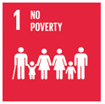 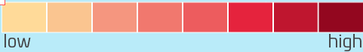

## Colors:

1. # FFDA99
2. # FAC590
3. # F5967F
4. # F1786E
5. # ED5C5E
6. # E5233D
7. # BF162F
8. # 93071F

# Zero Hunger

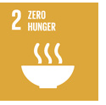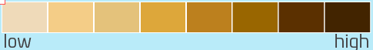

## Colors:

1. # EFDAB9
2. # F4CD87
3. # E4C27B
4. # DDA73A
5. # BC801E
6. # 996600
7. # 5B3000
8. # 422400

# Good Health & Well-Being

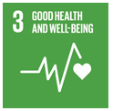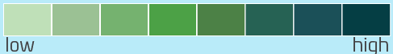

## Colors (low to high):

1. # BFE0B8
2. # 9BC194
3. # 75B26F
4. # 4CA146
5. # 4C8146
6. # 266254
7. # 1B5058
8. # 053E44

# Quality Education

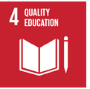 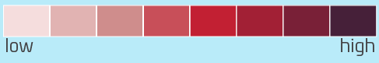

## Colors (low to high):

1. # F5DDDD
2. # E1B3B2
3. # CF8D8C
4. # C84F59
5. # C22033
6. # A22035
7. # 792037
8. # 462039

# Gender Equality

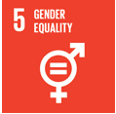 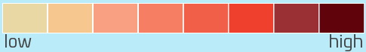

## Colors (low to high):

1. # EAD8A4
2. # F6C78F
3. # F8A081
4. # F57E63
5. # F25F48
6. # EF402D
7. # 9A3033
8. # 60030A

# Clean Water and Sanitation

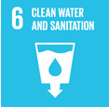 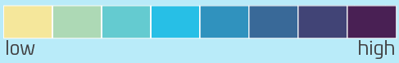

## Colors (low to high):

1. # F5E79B
2. # ADD9B5
3. # 64CBD0
4. # 27BFE6
5. # 3092BE
6. # 396998
7. # 414476
8. # 492054

# Affordable and Clean Energy

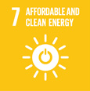 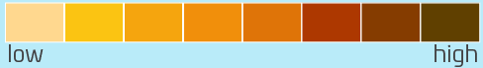

## Colors (low to high):

1. # FFD88F
2. # FBC412
3. # F5A50E
4. # F18F0B
5. # DF7408
6. # AD3800
7. # 853C00
8. # 604000

# 8. Decent Work and Economic Growth

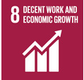 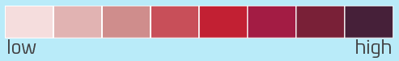

## Colors (low to high):

1. # F5DDDD
2. # E1B3B2
3. # CF8D8C
4. # C84F59
5. # C22033
6. # A31C44
7. # 792037
8. # 462039

# 9. Industry, Innovation, and Infrastructure

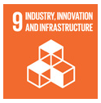 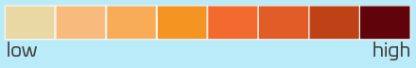

## Colors (low to high):

1. # EAD8A4
2. # F9BB7D
3. # F9AC58
4. # F49422
5. # F26A2E
6. # E25C27
7. # BF4116
8. # 60030A

# 10. Reduced Inequalities

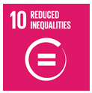 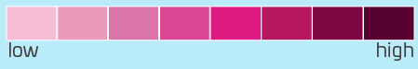

## Colors (low to high):

1. # F4BDD3
2. # EC99BA
3. # DA74AA
4. # DA4594
5. # E01A83
6. # B51860
7. # 7F0844
8. # 560130

# Sustainable Cities & Communities

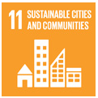 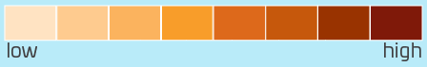

## Colors (low to high):

1. # FFE3C2
2. # FECB8F
3. # FBB35E
4. # F89D2A
5. # DD691B
6. # C6580C
7. # 993300
8. # 7F1909

# Responsible Consumption & Production

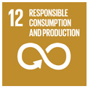 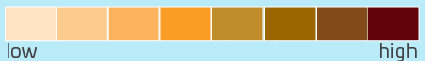

## Colors (low to high):

1. # FFE3C2
2. # FECB8F
3. # FBB35E
4. # F99D25
5. # BF8D2C
6. # 996600
7. # 824B19
8. # 60030A

# Climate Action

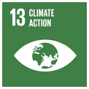 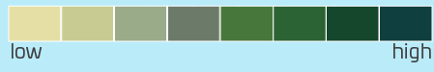

## Colors (low to high):

1. # E5DFA5
2. # C8CC93
3. # 99AB89
4. # 6C7B69
5. # 48773C
6. # 2C6334
7. # 14472B
8. # 103F3F

# Life Below Water

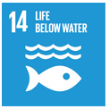 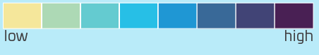

## Colors (low to high):

1. # F5E79B
2. # ADD9B5
3. # 64CBD0
4. # 27BFE6
5. # 1F97D4
6. # 396998
7. # 414476
8. # 492054

# Life On Land

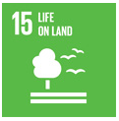 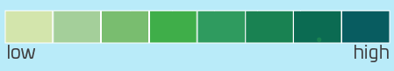

## Colors (low to high):

1. # D3E5AC
2. # A4CF9A
3. # 79BD6F
4. # 3FAE49
5. # 2F9B5F
6. # 198252
7. # 0B6B52
8. # 085C60

# Peace, Justice, & Strong Institutions

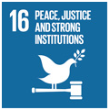 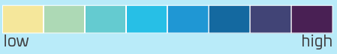

## Colors (low to high):

1. # F5E79B
2. # ADD9B5
3. # 64CBD0
4. # 27BFE6
5. # 1F97D4
6. # 1469A0
7. # 414476
8. # 492054

# Partnerships for the Goals

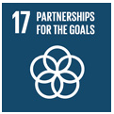 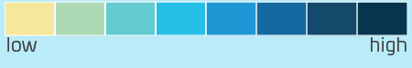

## Colors (low to high):

1. # F5E79B
2. # ADD9B5
3. # 64CBD0
4. # 27BFE6
5. # 1F97D4
6. # 1469A0
7. # 14496B
8. # 05354F

# Data for Sustainable Development

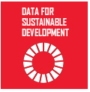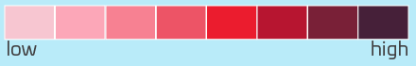

## Colors (low to high):

1. # F5DDDD
2. # E1B3B2
3. # CF8D8C
4. # C84F59
5. # EB1C2E
6. # A31C44
7. # 792037
8. # 462039